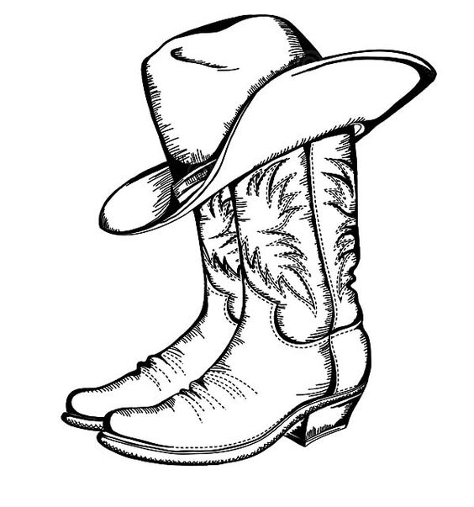
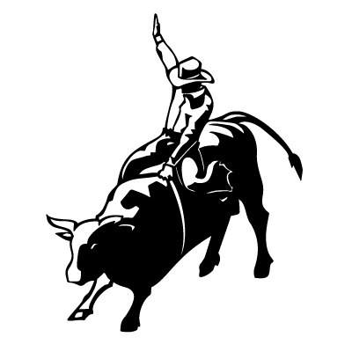
HAMEL LIONS RODEO PARADE
619 Hamel Road
Hamel, MN 55340

The Hamel Lions Rodeo Parade committee would like to thank you for all your past contributions which have made the Parade a success over the last 30 years! Each year the parade is held along Uptown Hamel starting at 2:00pm prior to Sunday’s performance of the World’s Championship Hamel Rodeo at the Corcoran Lions Park.

The Parade committee is a volunteer organization and funding for our Parade relies solely on your contributions. Please consider making a contribution to the 2022 Parade which will take place on Sunday July 10th starting at 2:00pm, the names of all contributors will be listed on the parade program handed out to viewers before the parade.

Donation Level (circle one):
Clowning Around $50
Stars and Stripes $100
Float Party $200
Grand Marshal $500
Other_________________
(please enter amount)

Also, consider being a part of our Parade, it’s a great way to advertise your business to the public and it’s a lot of FUN! For your convenience, a parade entry form is included.

The Hamel Lions Rodeo Parade operates through the Hamel Lions which is a non-profit charitable 501c3 organization, dedicated to the humanitarian services for groups and individuals in the local communities. All donations are tax deductible and checks should be made payable to the Hamel Lions.

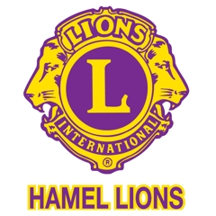
Any questions call Katie 612-636-1912, Kim 612-508-4962 or Deb 612-751-8215

